EKG
EKG Order is placed in PowerChart
Go to (quick orders) QO – Cardiology
Office procedures and select EKG office
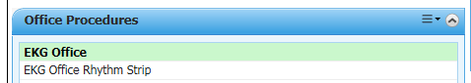
Click on the shopping cart
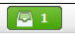
Select modify to add diagnosis code, details, or comments
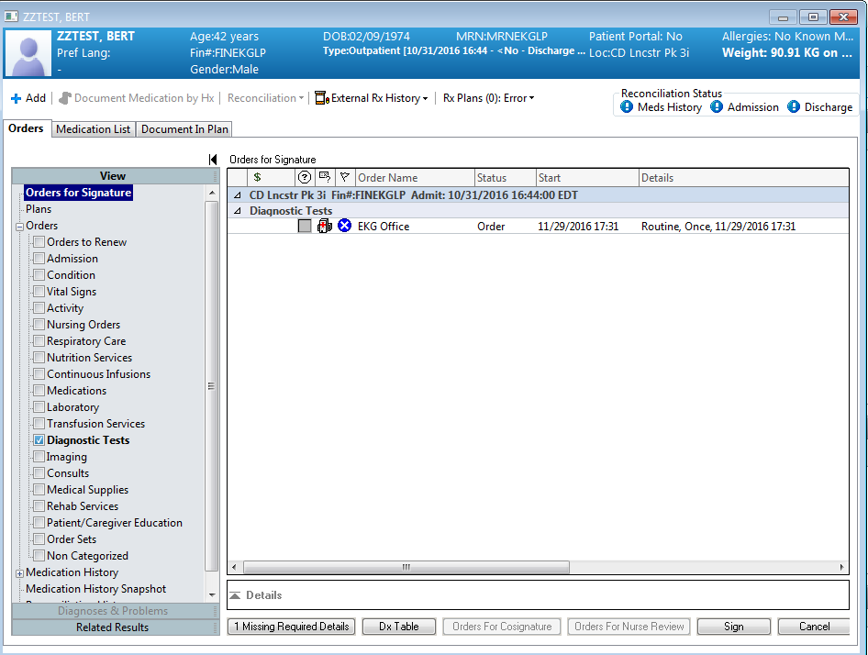
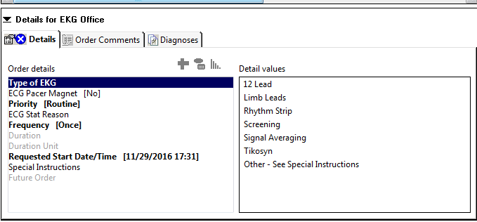
If diagnosis already exists, click on diagnosis to attach diagnosis to order
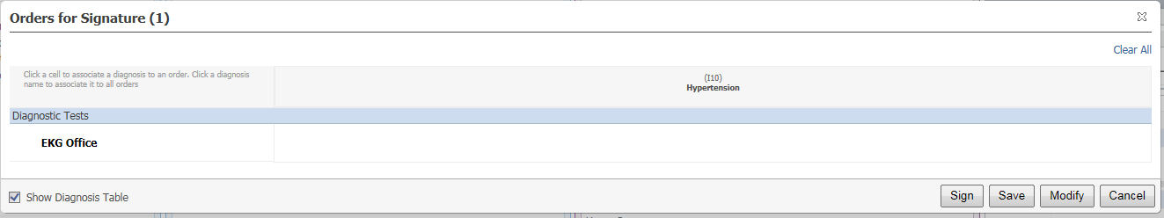
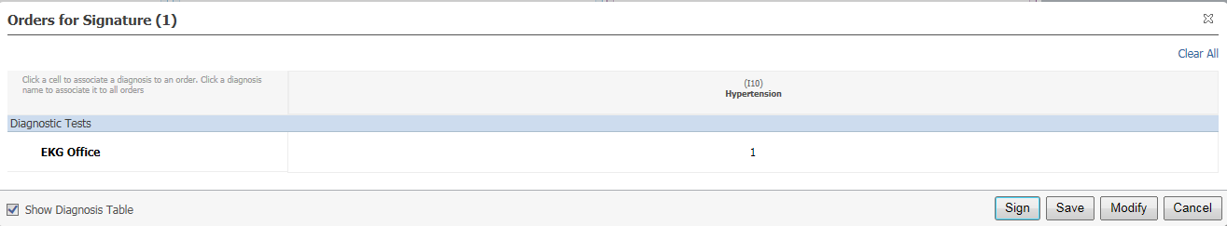
Select sign
Order is sent to the EKG cart.
The tech will complete the EKG.
Provide can review EKG in workflow under diagnostics, Cardiovascular worklist, or flowsheet.
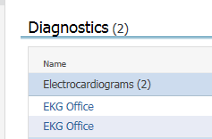
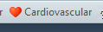
Click on the EKG to open
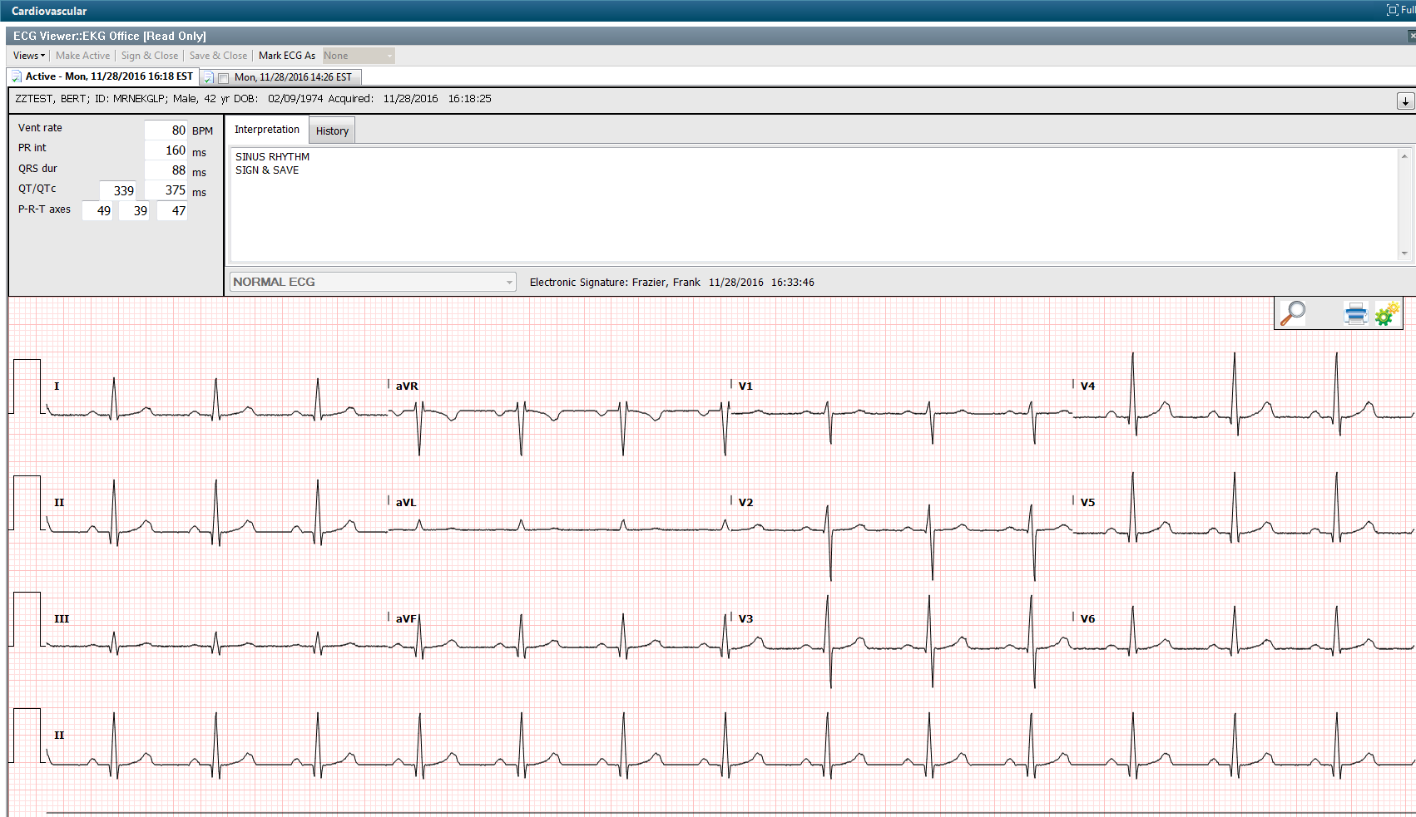
Click on the interpretation field and type, quick text, or use Dragon to add interpretation.
Select sign and close
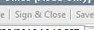
Electronic Signature of the provider will display
