Microviewer Training
Autumn 2013
New Microviewer In PowerChart
MicroViewer provides a quick review of the most pertinent microbiology results with the ability to access previous culture results for the patient. When a Microbiology result or order is selected the result viewing pane opens and displays the entire report associated with the specific order.
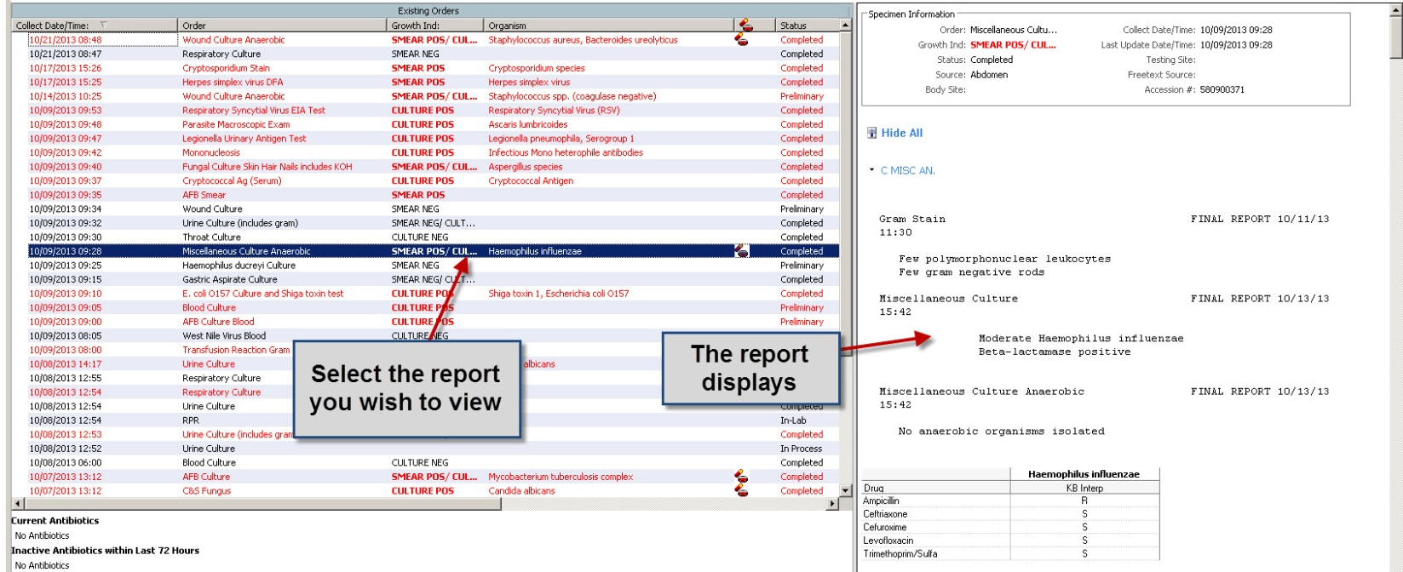

The following is displayed in the MicroViewer pane:
- Collected Date/Time
- Order
- Growth Indicator
- Organism
- Status
- Source/Body Site
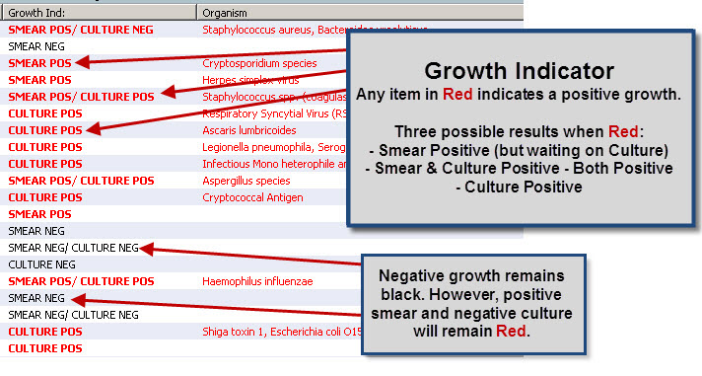
Growth Indicator:
- Any positive growth displays in red
- Negative cultures display in black when culture is finaled
- If a positive smear combines with a negative culture the item will remain red

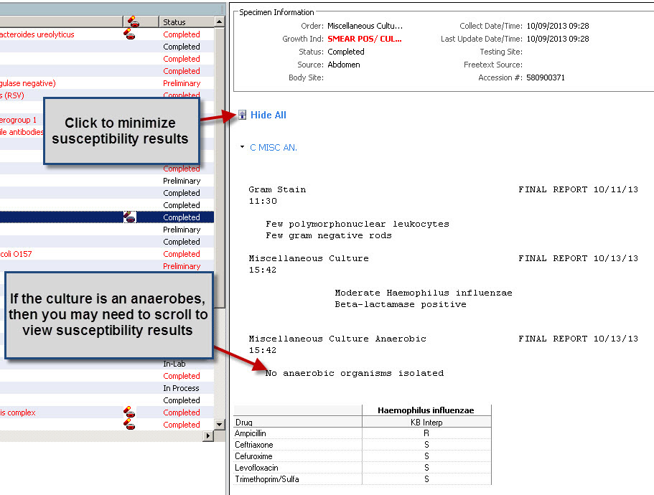
Viewing a report:
- Specimen details appear at the top
- Susceptibility results appear next, but if the culture is an anaerobes you may need to scroll

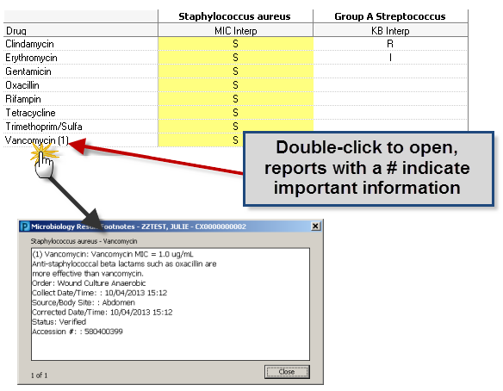
To view susceptibility details for a specific result:
Any drugs with a number indicate important information regarding specific organisms and/or drugs
- Select a row from the Susceptibility Report.
- Double-click any cell with a result posted.
- The Susceptibility Details window is displayed, allowing you to view footnotes and drug comments.
- To exit the window, click Close.

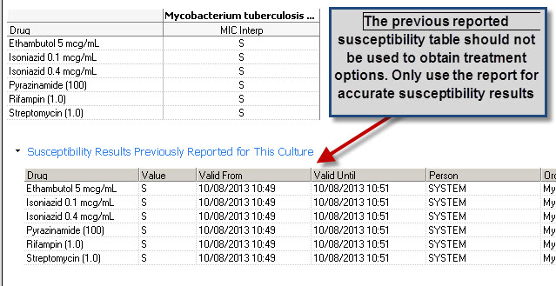

Previous Susceptibility Report:
- This report should not be used to obtain treatment options

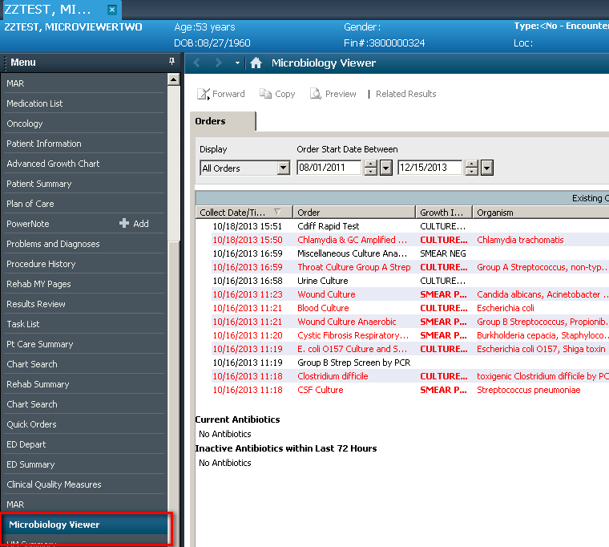
The MicroViewer can be found in the table of contents on the left or as a tab in Results Review.

